Environment Build Report
Class: How to Use AI for Sociological Research – SOC 910
Fall 2026
Professor: Dr. ChangHwan Kim
Student: Matheus Romanetto

This report was generated by Claude itself, following the structure of titles and headlines I ordered it to produce. Screenshots and commentary are my own authorship.
Since the actual setup process was generally conducted using plain English, I asked Claude to condense the main steps in setting up the environment into code here, so the process can be recorded in shorter form.

1. VS Code with Claude Code

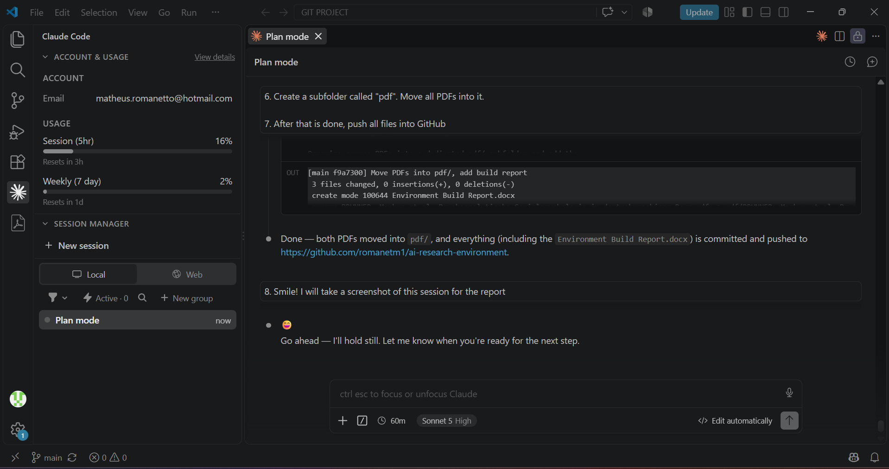
Claude has been running fine in my computer. There are redundancies between the CLAUDE.md file and the skills files, as I essentially converted prior CLAUDE.md commands into skills, without specifying other reproducible tasks yet. I will later disassemble the skills from the general .md file, and refine the general instructions to account for other dimensions of my research needs.

2. GitHub Repository
https://github.com/romanetm1/ai-research-environment
This repository is offered as a “sample” of all the operations whose evidence the assignment requires. I haven’t yet had the time to organize “real” projects, with more PDFs and actual tasks.
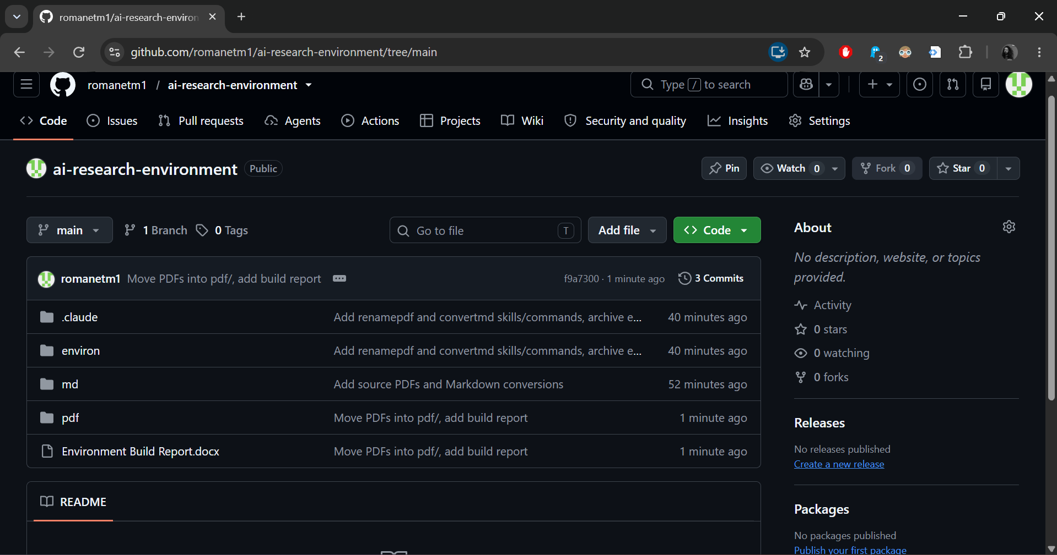
Included are a couple of PDF files converted to Markdown and named following an established convention, all done by Claude itself. The “environ” subfolder contains the essential .md files for Claude to operate as it currently does. It was generated prior to the .claude folder, which was pushed into GitHub later, and contains basically the same documentation.

3. MCPs for Zotero and Obsidian
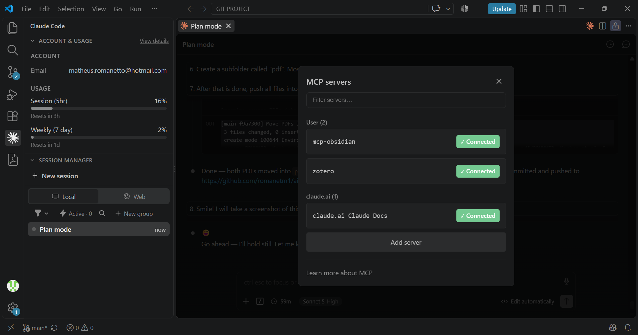
Everything seems to be running fine with both Zotero and Obsidian. I did a couple of trial commands directly from VS Code, and Claude was able to operate within both softwares. However, I am still deciding how exactly I want the architecture of my Personal Wiki, so there is nothing to show in either software.

4. Setup Build
1. VS Code + Claude Code
winget install Microsoft.VisualStudioCode
code --install-extension anthropic.claude-code
claude --version
2. Git + GitHub repository
git init
git branch -M main
git config user.name "romanetm1"
git config user.email "64726991+romanetm1@users.noreply.github.com"
git add <files>
git commit -m "<message>"
gh repo create ai-research-environment --public --source=. --remote=origin --push
3. MCP servers
pip install zotero-mcp
claude mcp add zotero -- zotero-mcp
pip install mcp-obsidian
claude mcp add mcp-obsidian -- mcp-obsidian
claude mcp list # verify: connected
4. Skills & slash commands
mkdir .claude/skills/renamepdf .claude/skills/convertmd .claude/commands
# add SKILL.md (renamepdf, convertmd) + matching command .md files
cp -r .claude/skills .claude/commands environ/
cp -r .claude/skills/* ~/.claude/skills/
cp -r .claude/commands/* ~/.claude/commands/

